Sensors choice

Different range:

* 0-100A: 17 sensors needed, with a maximum required diameter of 12mm
* 0-200A: 4 sensors needed, with a maximum required diameter of 16mm
* 0-400A: 2 sensors needed, with a maximum required diameter of 23mm
* 0-1000A: 1 sensors needed, with a maximum required diameter of 60mm

# Devices chosen

## 0-100A range

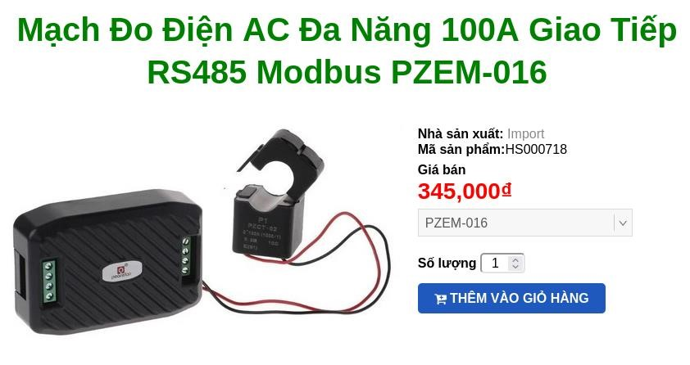

<https://hshop.vn/products/mach-do-dien-ac-da-nang-100a-giao-tiep-rs485-modbus-pzem-016>

Price: 345.000d

Hole: 15mm

Supply: AC220V

Communication: RS485

## 200A range main choice

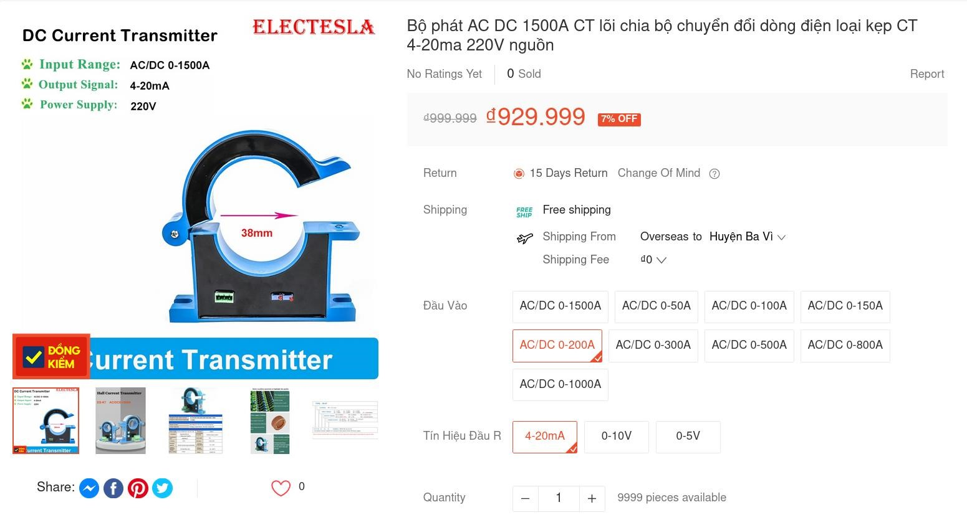

[https://shopee.vn/B%E1%BB%99-ph%C3%A1t-AC-DC-1500A-CT-l%C3%B5i-chia-b%E1%BB%99chuy%E1%BB%83n-%C4%91%E1%BB%95i-d%C3%B2ng-%C4%91i%E1%BB%87n-lo%E1%BA%A1i-k%E1%BA%B9p-CT-4-20ma-220Vngu%E1%BB%93n-i.906739781.28701621939?sp_atk=ed548e97-978f-4a36-938e-24cb982d86de&xptdk=ed548e97-978f-4a36-938e24cb982d86de](https://shopee.vn/B%E1%BB%99-ph%C3%A1t-AC-DC-1500A-CT-l%C3%B5i-chia-b%E1%BB%99-chuy%E1%BB%83n-%C4%91%E1%BB%95i-d%C3%B2ng-%C4%91i%E1%BB%87n-lo%E1%BA%A1i-k%E1%BA%B9p-CT-4-20ma-220V-ngu%E1%BB%93n-i.906739781.28701621939?sp_atk=ed548e97-978f-4a36-938e-24cb982d86de&xptdk=ed548e97-978f-4a36-938e-24cb982d86de)

Price: 929.999d

Hole: 38mm

Supply: AC220V

Reading value: measure output current 4-20mA

Advantage:

* Same sensor as other range, facilitating for Development Disadvantage:
* Price

## 400A range

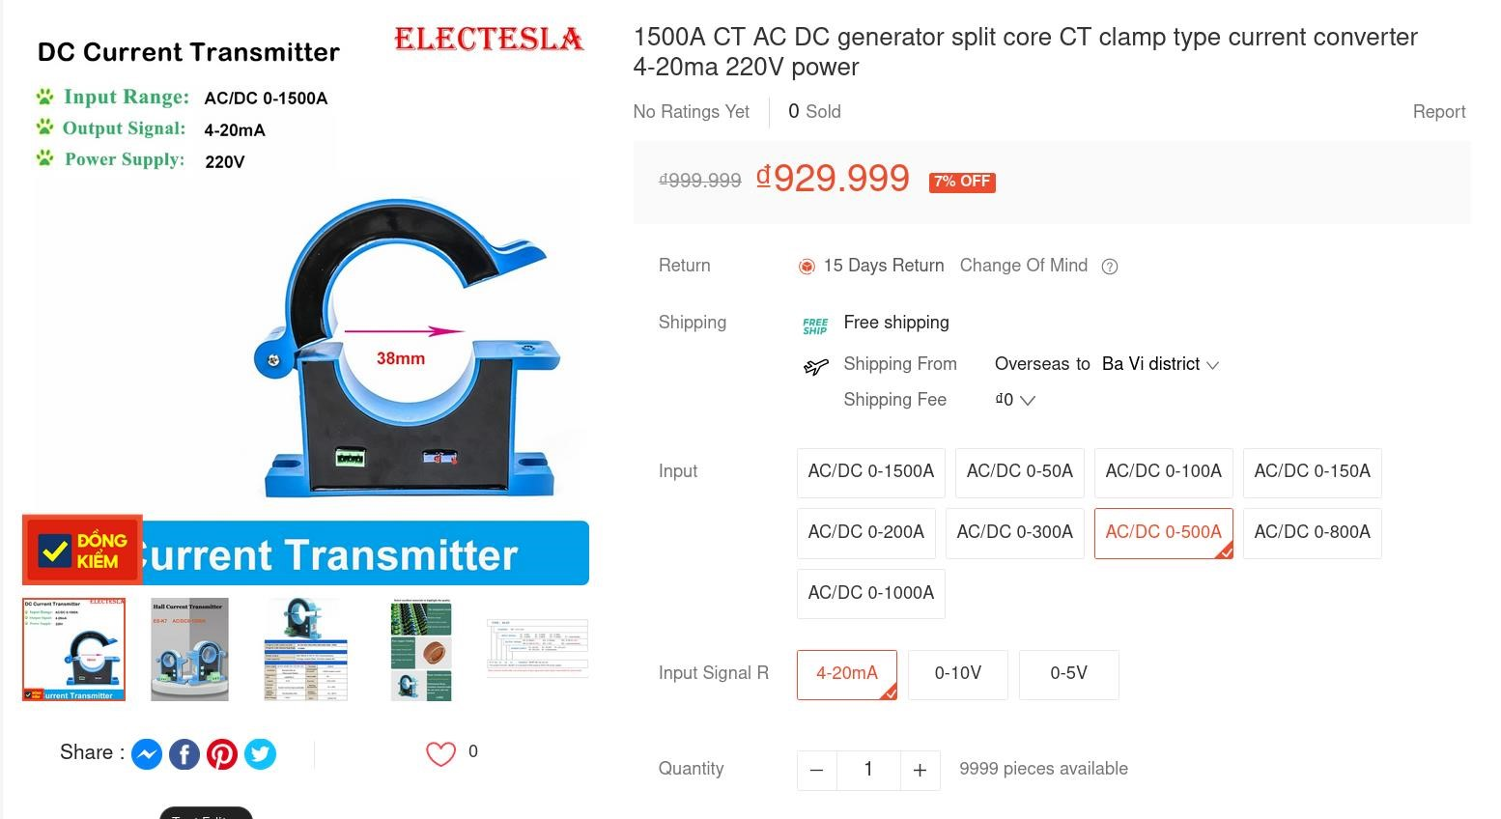

[https://shopee.vn/B%E1%BB%99-ph%C3%A1t-AC-DC-1500A-CT-l%C3%B5i-chia-b%E1%BB%99chuy%E1%BB%83n-%C4%91%E1%BB%95i-d%C3%B2ng-%C4%91i%E1%BB%87n-lo%E1%BA%A1i-k%E1%BA%B9p-CT-4-20ma-220Vngu%E1%BB%93n-i.906739781.28701621939?sp_atk=ed548e97-978f-4a36-938e-24cb982d86de&xptdk=ed548e97-978f-4a36-938e24cb982d86de](https://shopee.vn/B%E1%BB%99-ph%C3%A1t-AC-DC-1500A-CT-l%C3%B5i-chia-b%E1%BB%99-chuy%E1%BB%83n-%C4%91%E1%BB%95i-d%C3%B2ng-%C4%91i%E1%BB%87n-lo%E1%BA%A1i-k%E1%BA%B9p-CT-4-20ma-220V-ngu%E1%BB%93n-i.906739781.28701621939?sp_atk=ed548e97-978f-4a36-938e-24cb982d86de&xptdk=ed548e97-978f-4a36-938e-24cb982d86de)

Price: 929.999d

Hole: 38mm

Supply: AC220V

Reading value: measure output current 4-20mA

Advantage:

* Same sensor as other range, facilitating for Development Disadvantage:
* Price

## 1000A range

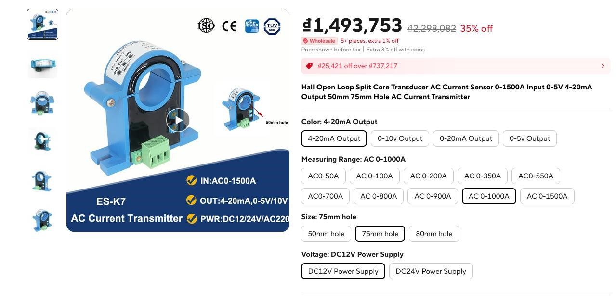

[https://www.aliexpress.us/item/3256803836177187.html?gps-](https://www.aliexpress.us/item/3256803836177187.html?gps-id=pcStoreJustForYou&scm=1007.23125.137358.0&scm_id=1007.23125.137358.0&scm-url=1007.23125.137358.0&pvid=00789f1e-5c64-46b2-abb8-7282e187f521&_t=gps-id%3ApcStoreJustForYou%2Cscm-url%3A1007.23125.137358.0%2Cpvid%3A00789f1e-5c64-46b2-abb8-7282e187f521%2Ctpp_buckets%3A668%232846%238107%231934&pdp_npi=4%40dis%21USD%2190.40%2158.76%21%21%2190.40%2158.76%21%402140fc6317180869977248270e3596%2112000027774694387%21rec%21US%21%21AB&spm=a2g0o.store_pc_home.smartJustForYou_2003970634588.1005004022491939&gatewayAdapt=glo2usa)

[id=pcStoreJustForYou&scm=1007.23125.137358.0&scm_id=1007.23125.137358.0&scm-url=1007.23125.137358.0&pvid=00789f1e-](https://www.aliexpress.us/item/3256803836177187.html?gps-id=pcStoreJustForYou&scm=1007.23125.137358.0&scm_id=1007.23125.137358.0&scm-url=1007.23125.137358.0&pvid=00789f1e-5c64-46b2-abb8-7282e187f521&_t=gps-id%3ApcStoreJustForYou%2Cscm-url%3A1007.23125.137358.0%2Cpvid%3A00789f1e-5c64-46b2-abb8-7282e187f521%2Ctpp_buckets%3A668%232846%238107%231934&pdp_npi=4%40dis%21USD%2190.40%2158.76%21%21%2190.40%2158.76%21%402140fc6317180869977248270e3596%2112000027774694387%21rec%21US%21%21AB&spm=a2g0o.store_pc_home.smartJustForYou_2003970634588.1005004022491939&gatewayAdapt=glo2usa)

[7282e187f521&_t=gps-id%3ApcStoreJustForYou%2Cscm-url%3A1007.23125.137358.0%2Cpvid%3A00789f1e-5c64-](https://www.aliexpress.us/item/3256803836177187.html?gps-id=pcStoreJustForYou&scm=1007.23125.137358.0&scm_id=1007.23125.137358.0&scm-url=1007.23125.137358.0&pvid=00789f1e-5c64-46b2-abb8-7282e187f521&_t=gps-id%3ApcStoreJustForYou%2Cscm-url%3A1007.23125.137358.0%2Cpvid%3A00789f1e-5c64-46b2-abb8-7282e187f521%2Ctpp_buckets%3A668%232846%238107%231934&pdp_npi=4%40dis%21USD%2190.40%2158.76%21%21%2190.40%2158.76%21%402140fc6317180869977248270e3596%2112000027774694387%21rec%21US%21%21AB&spm=a2g0o.store_pc_home.smartJustForYou_2003970634588.1005004022491939&gatewayAdapt=glo2usa)

[5](https://www.aliexpress.us/item/3256803836177187.html?gps-id=pcStoreJustForYou&scm=1007.23125.137358.0&scm_id=1007.23125.137358.0&scm-url=1007.23125.137358.0&pvid=00789f1e-5c64-46b2-abb8-7282e187f521&_t=gps-id%3ApcStoreJustForYou%2Cscm-url%3A1007.23125.137358.0%2Cpvid%3A00789f1e-5c64-46b2-abb8-7282e187f521%2Ctpp_buckets%3A668%232846%238107%231934&pdp_npi=4%40dis%21USD%2190.40%2158.76%21%21%2190.40%2158.76%21%402140fc6317180869977248270e3596%2112000027774694387%21rec%21US%21%21AB&spm=a2g0o.store_pc_home.smartJustForYou_2003970634588.1005004022491939&gatewayAdapt=glo2usa)

[6](https://www.aliexpress.us/item/3256803836177187.html?gps-id=pcStoreJustForYou&scm=1007.23125.137358.0&scm_id=1007.23125.137358.0&scm-url=1007.23125.137358.0&pvid=00789f1e-5c64-46b2-abb8-7282e187f521&_t=gps-id%3ApcStoreJustForYou%2Cscm-url%3A1007.23125.137358.0%2Cpvid%3A00789f1e-5c64-46b2-abb8-7282e187f521%2Ctpp_buckets%3A668%232846%238107%231934&pdp_npi=4%40dis%21USD%2190.40%2158.76%21%21%2190.40%2158.76%21%402140fc6317180869977248270e3596%2112000027774694387%21rec%21US%21%21AB&spm=a2g0o.store_pc_home.smartJustForYou_2003970634588.1005004022491939&gatewayAdapt=glo2usa)

[4](https://www.aliexpress.us/item/3256803836177187.html?gps-id=pcStoreJustForYou&scm=1007.23125.137358.0&scm_id=1007.23125.137358.0&scm-url=1007.23125.137358.0&pvid=00789f1e-5c64-46b2-abb8-7282e187f521&_t=gps-id%3ApcStoreJustForYou%2Cscm-url%3A1007.23125.137358.0%2Cpvid%3A00789f1e-5c64-46b2-abb8-7282e187f521%2Ctpp_buckets%3A668%232846%238107%231934&pdp_npi=4%40dis%21USD%2190.40%2158.76%21%21%2190.40%2158.76%21%402140fc6317180869977248270e3596%2112000027774694387%21rec%21US%21%21AB&spm=a2g0o.store_pc_home.smartJustForYou_2003970634588.1005004022491939&gatewayAdapt=glo2usa)

[c](https://www.aliexpress.us/item/3256803836177187.html?gps-id=pcStoreJustForYou&scm=1007.23125.137358.0&scm_id=1007.23125.137358.0&scm-url=1007.23125.137358.0&pvid=00789f1e-5c64-46b2-abb8-7282e187f521&_t=gps-id%3ApcStoreJustForYou%2Cscm-url%3A1007.23125.137358.0%2Cpvid%3A00789f1e-5c64-46b2-abb8-7282e187f521%2Ctpp_buckets%3A668%232846%238107%231934&pdp_npi=4%40dis%21USD%2190.40%2158.76%21%21%2190.40%2158.76%21%402140fc6317180869977248270e3596%2112000027774694387%21rec%21US%21%21AB&spm=a2g0o.store_pc_home.smartJustForYou_2003970634588.1005004022491939&gatewayAdapt=glo2usa)

[-](https://www.aliexpress.us/item/3256803836177187.html?gps-id=pcStoreJustForYou&scm=1007.23125.137358.0&scm_id=1007.23125.137358.0&scm-url=1007.23125.137358.0&pvid=00789f1e-5c64-46b2-abb8-7282e187f521&_t=gps-id%3ApcStoreJustForYou%2Cscm-url%3A1007.23125.137358.0%2Cpvid%3A00789f1e-5c64-46b2-abb8-7282e187f521%2Ctpp_buckets%3A668%232846%238107%231934&pdp_npi=4%40dis%21USD%2190.40%2158.76%21%21%2190.40%2158.76%21%402140fc6317180869977248270e3596%2112000027774694387%21rec%21US%21%21AB&spm=a2g0o.store_pc_home.smartJustForYou_2003970634588.1005004022491939&gatewayAdapt=glo2usa)

46

[2](https://www.aliexpress.us/item/3256803836177187.html?gps-id=pcStoreJustForYou&scm=1007.23125.137358.0&scm_id=1007.23125.137358.0&scm-url=1007.23125.137358.0&pvid=00789f1e-5c64-46b2-abb8-7282e187f521&_t=gps-id%3ApcStoreJustForYou%2Cscm-url%3A1007.23125.137358.0%2Cpvid%3A00789f1e-5c64-46b2-abb8-7282e187f521%2Ctpp_buckets%3A668%232846%238107%231934&pdp_npi=4%40dis%21USD%2190.40%2158.76%21%21%2190.40%2158.76%21%402140fc6317180869977248270e3596%2112000027774694387%21rec%21US%21%21AB&spm=a2g0o.store_pc_home.smartJustForYou_2003970634588.1005004022491939&gatewayAdapt=glo2usa)

[b](https://www.aliexpress.us/item/3256803836177187.html?gps-id=pcStoreJustForYou&scm=1007.23125.137358.0&scm_id=1007.23125.137358.0&scm-url=1007.23125.137358.0&pvid=00789f1e-5c64-46b2-abb8-7282e187f521&_t=gps-id%3ApcStoreJustForYou%2Cscm-url%3A1007.23125.137358.0%2Cpvid%3A00789f1e-5c64-46b2-abb8-7282e187f521%2Ctpp_buckets%3A668%232846%238107%231934&pdp_npi=4%40dis%21USD%2190.40%2158.76%21%21%2190.40%2158.76%21%402140fc6317180869977248270e3596%2112000027774694387%21rec%21US%21%21AB&spm=a2g0o.store_pc_home.smartJustForYou_2003970634588.1005004022491939&gatewayAdapt=glo2usa)

[-](https://www.aliexpress.us/item/3256803836177187.html?gps-id=pcStoreJustForYou&scm=1007.23125.137358.0&scm_id=1007.23125.137358.0&scm-url=1007.23125.137358.0&pvid=00789f1e-5c64-46b2-abb8-7282e187f521&_t=gps-id%3ApcStoreJustForYou%2Cscm-url%3A1007.23125.137358.0%2Cpvid%3A00789f1e-5c64-46b2-abb8-7282e187f521%2Ctpp_buckets%3A668%232846%238107%231934&pdp_npi=4%40dis%21USD%2190.40%2158.76%21%21%2190.40%2158.76%21%402140fc6317180869977248270e3596%2112000027774694387%21rec%21US%21%21AB&spm=a2g0o.store_pc_home.smartJustForYou_2003970634588.1005004022491939&gatewayAdapt=glo2usa)

[8](https://www.aliexpress.us/item/3256803836177187.html?gps-id=pcStoreJustForYou&scm=1007.23125.137358.0&scm_id=1007.23125.137358.0&scm-url=1007.23125.137358.0&pvid=00789f1e-5c64-46b2-abb8-7282e187f521&_t=gps-id%3ApcStoreJustForYou%2Cscm-url%3A1007.23125.137358.0%2Cpvid%3A00789f1e-5c64-46b2-abb8-7282e187f521%2Ctpp_buckets%3A668%232846%238107%231934&pdp_npi=4%40dis%21USD%2190.40%2158.76%21%21%2190.40%2158.76%21%402140fc6317180869977248270e3596%2112000027774694387%21rec%21US%21%21AB&spm=a2g0o.store_pc_home.smartJustForYou_2003970634588.1005004022491939&gatewayAdapt=glo2usa)

abb

[-](https://www.aliexpress.us/item/3256803836177187.html?gps-id=pcStoreJustForYou&scm=1007.23125.137358.0&scm_id=1007.23125.137358.0&scm-url=1007.23125.137358.0&pvid=00789f1e-5c64-46b2-abb8-7282e187f521&_t=gps-id%3ApcStoreJustForYou%2Cscm-url%3A1007.23125.137358.0%2Cpvid%3A00789f1e-5c64-46b2-abb8-7282e187f521%2Ctpp_buckets%3A668%232846%238107%231934&pdp_npi=4%40dis%21USD%2190.40%2158.76%21%21%2190.40%2158.76%21%402140fc6317180869977248270e3596%2112000027774694387%21rec%21US%21%21AB&spm=a2g0o.store_pc_home.smartJustForYou_2003970634588.1005004022491939&gatewayAdapt=glo2usa)

46

[2](https://www.aliexpress.us/item/3256803836177187.html?gps-id=pcStoreJustForYou&scm=1007.23125.137358.0&scm_id=1007.23125.137358.0&scm-url=1007.23125.137358.0&pvid=00789f1e-5c64-46b2-abb8-7282e187f521&_t=gps-id%3ApcStoreJustForYou%2Cscm-url%3A1007.23125.137358.0%2Cpvid%3A00789f1e-5c64-46b2-abb8-7282e187f521%2Ctpp_buckets%3A668%232846%238107%231934&pdp_npi=4%40dis%21USD%2190.40%2158.76%21%21%2190.40%2158.76%21%402140fc6317180869977248270e3596%2112000027774694387%21rec%21US%21%21AB&spm=a2g0o.store_pc_home.smartJustForYou_2003970634588.1005004022491939&gatewayAdapt=glo2usa)

[b](https://www.aliexpress.us/item/3256803836177187.html?gps-id=pcStoreJustForYou&scm=1007.23125.137358.0&scm_id=1007.23125.137358.0&scm-url=1007.23125.137358.0&pvid=00789f1e-5c64-46b2-abb8-7282e187f521&_t=gps-id%3ApcStoreJustForYou%2Cscm-url%3A1007.23125.137358.0%2Cpvid%3A00789f1e-5c64-46b2-abb8-7282e187f521%2Ctpp_buckets%3A668%232846%238107%231934&pdp_npi=4%40dis%21USD%2190.40%2158.76%21%21%2190.40%2158.76%21%402140fc6317180869977248270e3596%2112000027774694387%21rec%21US%21%21AB&spm=a2g0o.store_pc_home.smartJustForYou_2003970634588.1005004022491939&gatewayAdapt=glo2usa)

[-](https://www.aliexpress.us/item/3256803836177187.html?gps-id=pcStoreJustForYou&scm=1007.23125.137358.0&scm_id=1007.23125.137358.0&scm-url=1007.23125.137358.0&pvid=00789f1e-5c64-46b2-abb8-7282e187f521&_t=gps-id%3ApcStoreJustForYou%2Cscm-url%3A1007.23125.137358.0%2Cpvid%3A00789f1e-5c64-46b2-abb8-7282e187f521%2Ctpp_buckets%3A668%232846%238107%231934&pdp_npi=4%40dis%21USD%2190.40%2158.76%21%21%2190.40%2158.76%21%402140fc6317180869977248270e3596%2112000027774694387%21rec%21US%21%21AB&spm=a2g0o.store_pc_home.smartJustForYou_2003970634588.1005004022491939&gatewayAdapt=glo2usa)

[8](https://www.aliexpress.us/item/3256803836177187.html?gps-id=pcStoreJustForYou&scm=1007.23125.137358.0&scm_id=1007.23125.137358.0&scm-url=1007.23125.137358.0&pvid=00789f1e-5c64-46b2-abb8-7282e187f521&_t=gps-id%3ApcStoreJustForYou%2Cscm-url%3A1007.23125.137358.0%2Cpvid%3A00789f1e-5c64-46b2-abb8-7282e187f521%2Ctpp_buckets%3A668%232846%238107%231934&pdp_npi=4%40dis%21USD%2190.40%2158.76%21%21%2190.40%2158.76%21%402140fc6317180869977248270e3596%2112000027774694387%21rec%21US%21%21AB&spm=a2g0o.store_pc_home.smartJustForYou_2003970634588.1005004022491939&gatewayAdapt=glo2usa)

abb

[-](https://www.aliexpress.us/item/3256803836177187.html?gps-id=pcStoreJustForYou&scm=1007.23125.137358.0&scm_id=1007.23125.137358.0&scm-url=1007.23125.137358.0&pvid=00789f1e-5c64-46b2-abb8-7282e187f521&_t=gps-id%3ApcStoreJustForYou%2Cscm-url%3A1007.23125.137358.0%2Cpvid%3A00789f1e-5c64-46b2-abb8-7282e187f521%2Ctpp_buckets%3A668%232846%238107%231934&pdp_npi=4%40dis%21USD%2190.40%2158.76%21%21%2190.40%2158.76%21%402140fc6317180869977248270e3596%2112000027774694387%21rec%21US%21%21AB&spm=a2g0o.store_pc_home.smartJustForYou_2003970634588.1005004022491939&gatewayAdapt=glo2usa)

[7282e187f521%2Ctpp_buckets%3A668%232846%238107%231934&pdp_npi=4%40dis%21USD%2190.40%2158.76%21%21%2190.40 %2158.76%21%402140fc6317180869977248270e3596%2112000027774694387%21rec%21US%21%21AB&spm=a2g0o.store_pc_hom e.smartJustForYou_2003970634588.1005004022491939&gatewayAdapt=glo2usa](https://www.aliexpress.us/item/3256803836177187.html?gps-id=pcStoreJustForYou&scm=1007.23125.137358.0&scm_id=1007.23125.137358.0&scm-url=1007.23125.137358.0&pvid=00789f1e-5c64-46b2-abb8-7282e187f521&_t=gps-id%3ApcStoreJustForYou%2Cscm-url%3A1007.23125.137358.0%2Cpvid%3A00789f1e-5c64-46b2-abb8-7282e187f521%2Ctpp_buckets%3A668%232846%238107%231934&pdp_npi=4%40dis%21USD%2190.40%2158.76%21%21%2190.40%2158.76%21%402140fc6317180869977248270e3596%2112000027774694387%21rec%21US%21%21AB&spm=a2g0o.store_pc_home.smartJustForYou_2003970634588.1005004022491939&gatewayAdapt=glo2usa)

Price: 1.493.753d

Hole: 75mm

Supply: 12V DC

Reading value: measure output current 4-20mA

Advantage :

* Same sensor as other range, facilitating for Developpement Disadvantage:
* Price

# Other interesting sensors

## Other sensor n1

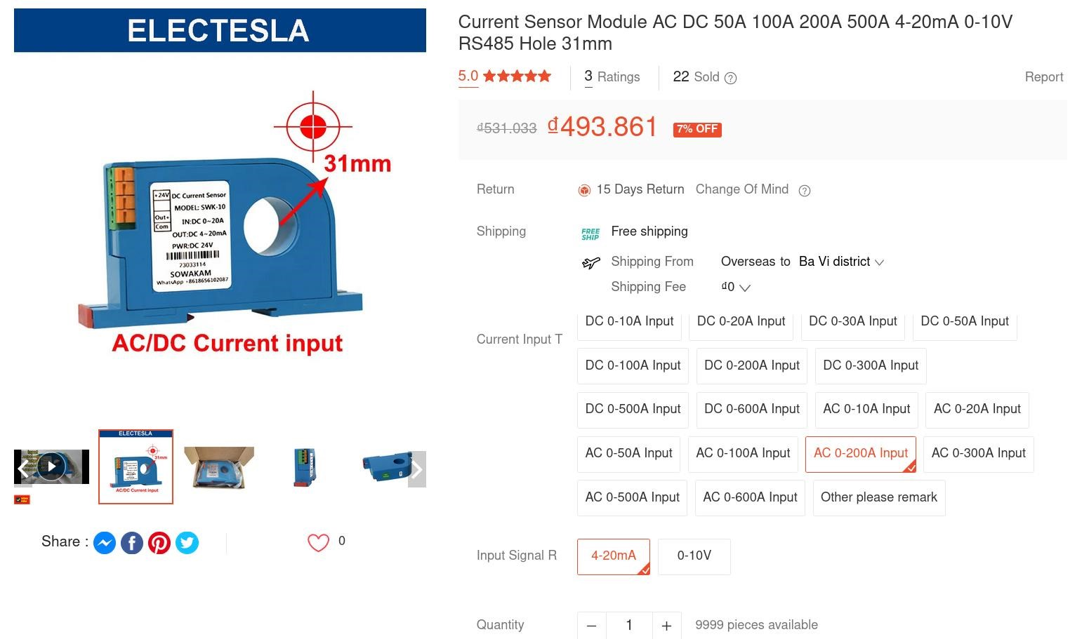

[https://shopee.vn/M%C3%B4-%C4%90un-C%E1%BA%A3m-Bi%E1%BA%BFn-D%C3%B2ng-%C4%90i%E1%BB%87n-AC-DC-50A100A-200A-500A-4-20mA-0-10V-RS485-L%E1%BB%97-31mm-i.906739781.21881508571?sp_atk=d7bda4cf-cc4e-48a3-9f0fbe16bb2adfc7&xptdk=d7bda4cf-cc4e-48a3-9f0f-be16bb2adfc7](https://shopee.vn/M%C3%B4-%C4%90un-C%E1%BA%A3m-Bi%E1%BA%BFn-D%C3%B2ng-%C4%90i%E1%BB%87n-AC-DC-50A-100A-200A-500A-4-20mA-0-10V-RS485-L%E1%BB%97-31mm-i.906739781.21881508571?sp_atk=d7bda4cf-cc4e-48a3-9f0f-be16bb2adfc7&xptdk=d7bda4cf-cc4e-48a3-9f0f-be16bb2adfc7)

Price: 493.861d

Hole: 31 mm

Supply: *Need to ask seller*

Reading value: measure output current 4-20mA Advantage :

* Price

Disadvantage:

* Different sensors than other range bc can t be use for 0-1000A

## Other sensor n2

Another sensor that less expensive but requires output conversion (the output is 5A). Example:

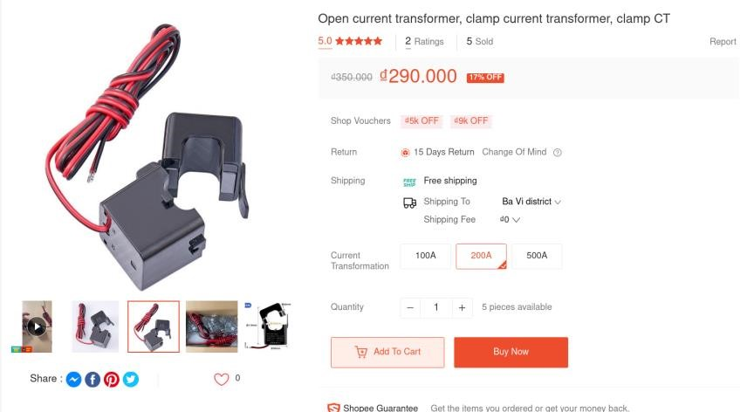

[https://shopee.vn/Bi%E1%BA%BFn-d%C3%B2ng-h%E1%BB%9F-bi%E1%BA%BFn-d%C3%B2ng-d%E1%BA%A1ng-k%E1%BA%B9pCT-k%E1%BA%B9p-i.90096722.25971478652?publish_id=&sp_atk=806820a8-a024-40e6-a946-49eb7f531268&xptdk=806820a8-a02440e6-a946-49eb7f531268](https://shopee.vn/Bi%E1%BA%BFn-d%C3%B2ng-h%E1%BB%9F-bi%E1%BA%BFn-d%C3%B2ng-d%E1%BA%A1ng-k%E1%BA%B9p-CT-k%E1%BA%B9p-i.90096722.25971478652?publish_id=&sp_atk=806820a8-a024-40e6-a946-49eb7f531268&xptdk=806820a8-a024-40e6-a946-49eb7f531268)

Advantage :

* Price

Disadvantage:

* The need of the convert
* Different sensors than other range bc can t be use for 0-1000A

## Other sensor n3

Another sensor that less expensive but requires output conversion (the output is 5A).

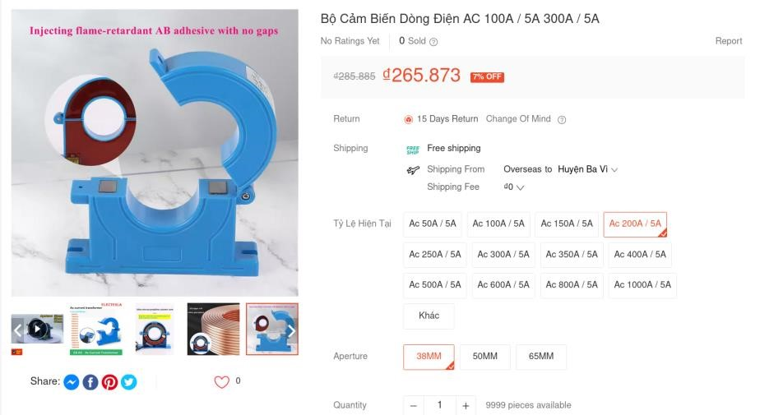

[https://shopee.vn/B%E1%BB%99-C%E1%BA%A3m-Bi%E1%BA%BFn-D%C3%B2ng-%C4%90i%E1%BB%87n-AC-100A-5A-300A-5Ai.906739781.25908605329?sp_atk=b1ef47a7-7275-40ae-a5bb-6746ed2d3863&xptdk=b1ef47a7-7275-40ae-a5bb-6746ed2d3863](https://shopee.vn/B%E1%BB%99-C%E1%BA%A3m-Bi%E1%BA%BFn-D%C3%B2ng-%C4%90i%E1%BB%87n-AC-100A-5A-300A-5A-i.906739781.25908605329?sp_atk=b1ef47a7-7275-40ae-a5bb-6746ed2d3863&xptdk=b1ef47a7-7275-40ae-a5bb-6746ed2d3863) Advantage :

* Price

Disadvantage:

* The need of the convert